Mr Descombe’s Python Hot Chili challenges - Lists

Choose an appropriate heat level and attempt to write the code up to that point.

Bell pepper programs:

1. 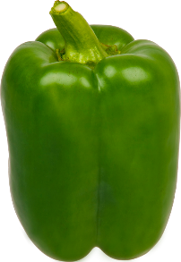Write a program that:

* Displays a list of 5 items i.e. Sushi, Tempura, Ramen, Teriyaki, Udon
* There should be a title to the list i.e. A list of Japanese foods:
* Each item should have a character(s) at the beginning to show it is a list item i.e. ->

1. Write a program that:

* Contains a list of items i.e. long jump, 100m, fencing etc.
* Allows the user to type in an item and returns if the item is in the list or not

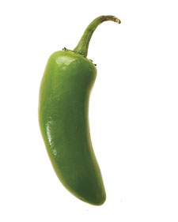Jalapeno programs:

1. Write the bell pepper program 1 and:

* Add automatic numbering for the items in the list

1. Write the bell pepper program 2 and:

* Returns the numeric position of the item in the list

Birds-eye programs:

1. 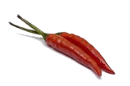Write the Jalapeno program 3 and:

* Allow the user to add a new item to the list and then re-display the list with the new item
* Give the user the option to add exit the program or add more items

1. Write the Jalapeno program 4 and:

* Ask the user if they want to search again or exit the program

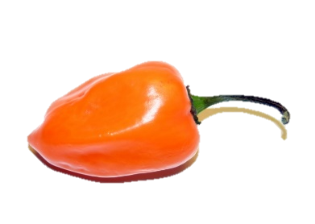Habanero programs:

1. Write either of the birds-eye programs and:

* If the user exits the program, save the items to a file



Jolokia programs:

1. Write a program that:

* Stores a name and score connected in a list
* Stores a list of the previous pair of data items
* Displays the list in a formatted way i.e. James – 200 points

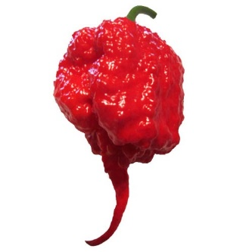Carolina Reaper

1. Write the Jolokia program and:

* Allow new names and scores to be added to the program
* Order the output of the programs so that the items are listed from highest to lowest